**1.** In experiment 2, we found that many neurons fire more action potentials when we touched the cockroach leg spines. What type of information encoding is this?

**A:** This is rate coding, which is the encoding of information via the rate of action potentials.

**2.**

**a)** Looking at the raster plots of neuron action potentials, are neuron responses to touch highly stereotyped or variable from trial to trial (pick one of these two options)?

**A:** They are variable from trial to trial. Each raster plot looks unique save for the fact that the rate of firing is higher at stimulus onset. This is a result of small variations in the testing, such as the force applied, how consistent it is (for experiment 3), angle, and whether the leg is fresh, or dying or dead due to repeated punctures of the electrodes.

**b)** Name at least one source of variability in your experiment that might limit your ability to assess the consistency of neuron responses, and propose an improvement to refine your measurements. (Note that you can propose using additional tools you were not provided in this lab!)

**A:** Variability includes the force and angle of the touch, along with consistency of the force, as well as the survivability of the leg for repeated testing. In the case of the former, a motorized manipulator is securely placed, along with the corkboard where the leg is pinned, is recommended. This removes the variability of the human hand and controls the pressure of tactile stimulation as well as angle. As for the latter, one way is to prepare specific locations beforehand on the leg where the pins are going to be punctured into. Another is to prepare more than one leg in the case the first leg is too damaged or has died.

**3.** In experiment 3, you should find that neuron firing responses are time-dependent (change over time for the same stimulus). Based on this observation, would it be possible to build a simple decoder that predicts the amount of force applied to the leg only based on the firing rate of recorded neurons? Why or why not?

**A:** No, as variability in the data as a result of the way the data is collected is an issue. This variability is caused by human error in applying inconsistent force onto the spine leg across the 10 seconds for each trial.

**4.** In experiment 1, you may have noticed that the same frequency of stimulation could produce different movements (e.g. flexion vs. extension of the leg) for different amplitudes of stimulation. Based on the properties of how electrical stimulation activates neurons, why might this occur?

**A:** We did not observe this in our experiment, but we did find that it didn’t change at different frequencies except at 5000Hz, across all volumes. But assuming that it did, the reason could be because different stimulus intensities activate different neuron populations, with the level of stimulus corresponding to the threshold for activation of the groups of neurons, and the number of neurons activated.

**5.** Experiments 2 and 3 (recording activity) suggest that neurons represent tactile stimulation, while the results from stimulation-based experiment 1 suggest that neural activity is involved in moving the leg. Do these results conflict with each other? Why or why not?

**A:** They do not, because these results display the function of the sensorimotor system. Signals from tactile stimulation are encoded into sensory neurons, which are then sent to motor neurons and decoded into movement.

**6.** Append the list of figures given at the end of each analysis script for experiments 2 and 3 (underlined in the experiment descriptions).

**A:**

**Experiment 2 (File/Spine 2)**

**Channel 1 (Femur) – Spike Waveforms**

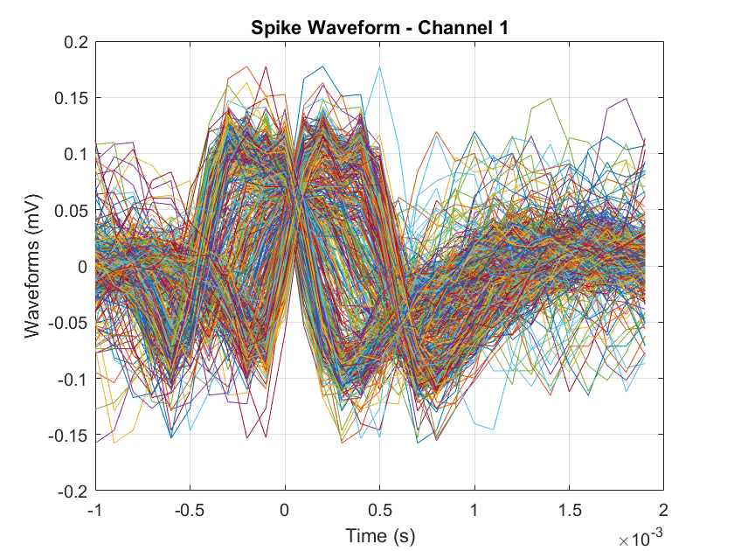

**Channel 1 (Femur) – Trial-Aligned Raster and PSTH**

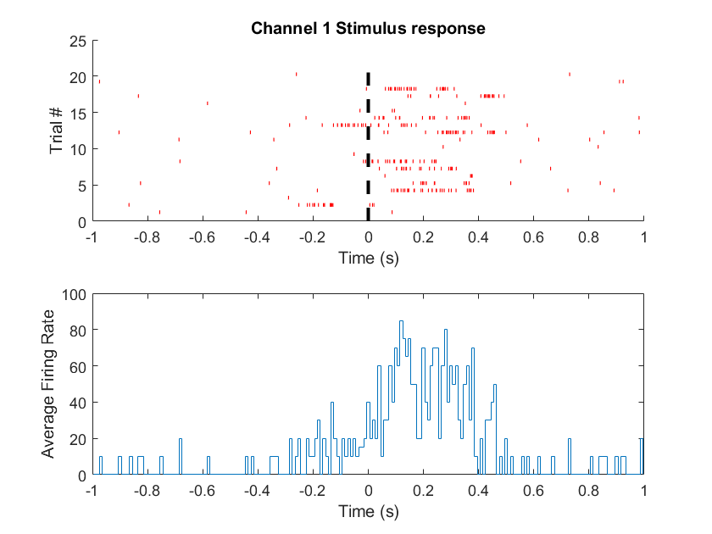

**Channel 2 (Tibia) – Spike Waveforms**

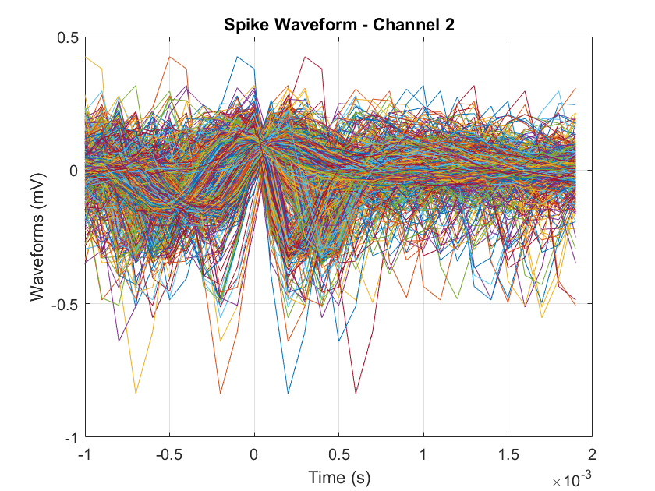

**Channel 2 (Tibia) – Trial-Aligned Raster and PSTH**

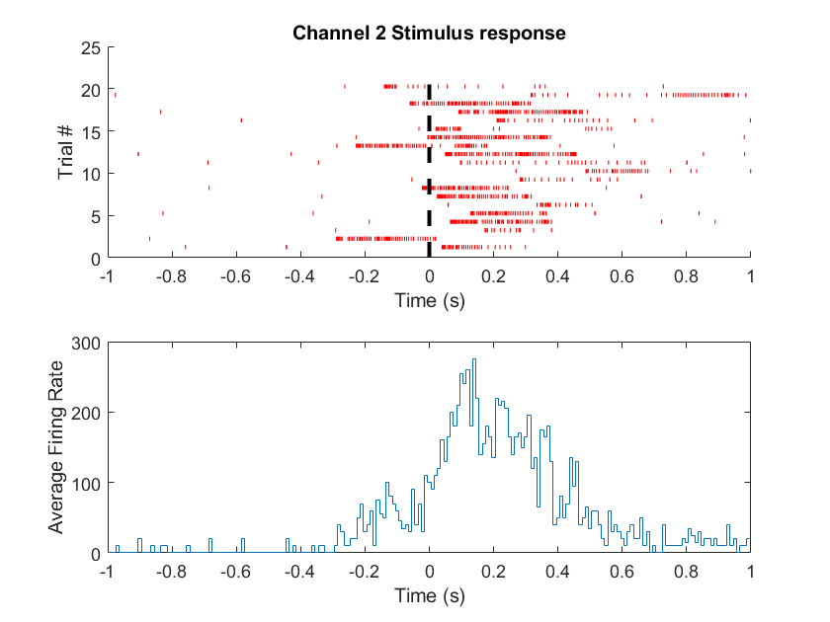

**Experiment 3 (File/Spine 2)**

**Channel 1 (Femur) – Spike Waveforms**

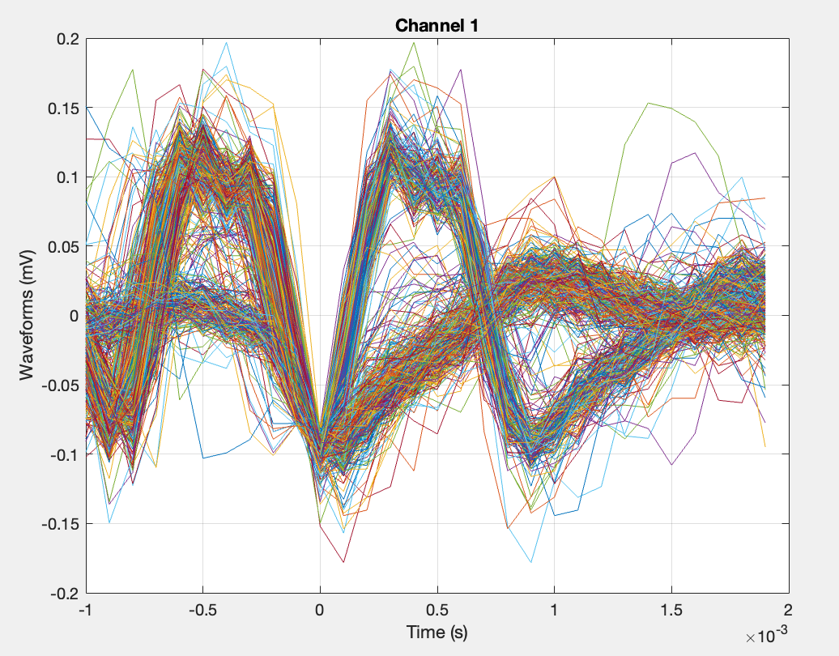

**Channel 2 (Tibia) – Trial-Aligned Raster and PSTH, Stim On**

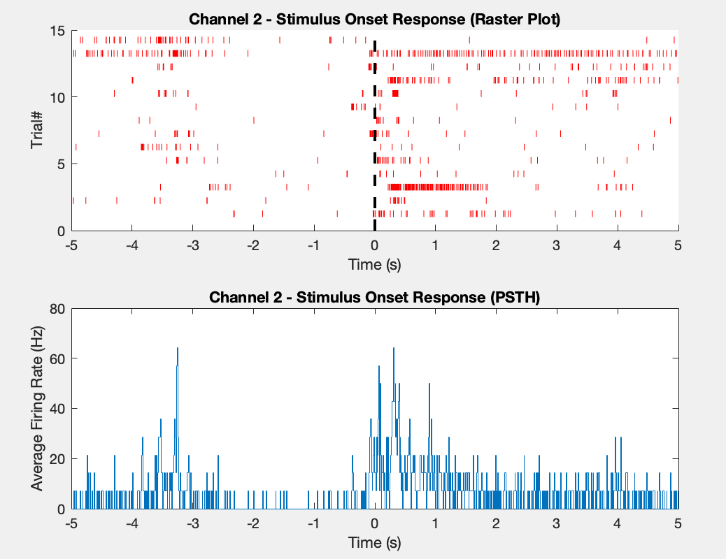

**Channel 2 (Tibia) – Trial-Aligned Raster and PSTH, Stim Off**

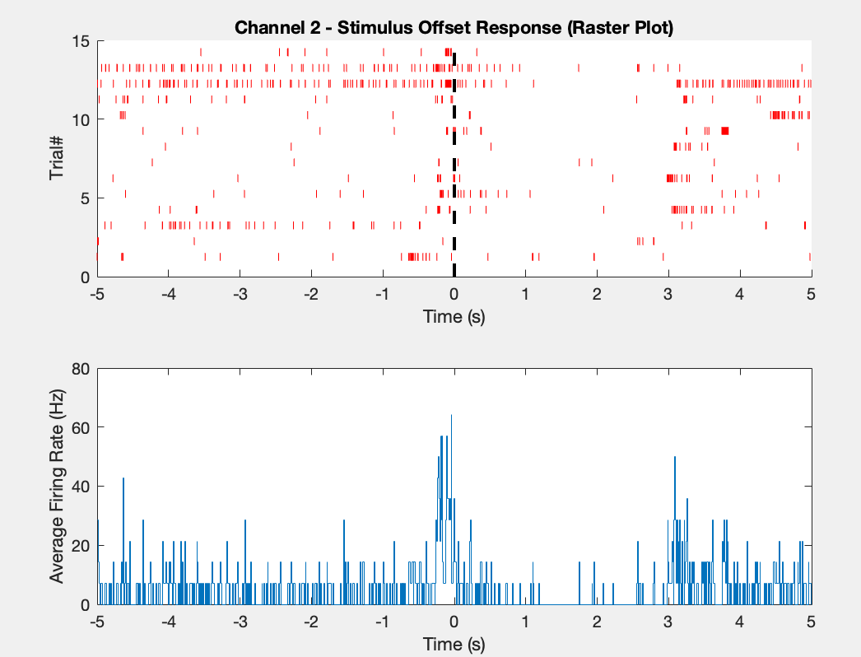

**Neural Response to Stimulus Changes Over Time (Temporal Dynamics)**

